Western Australian Certificate of Education
Applecross SHS, 2010

Question/Answer Booklet

BIOLOGICAL
SCIENCES
Write your name here:
Stage 3

Student Number: In figures

In words

Time allowed for this paper
Reading time before commencing work: ten minutes
Working time for paper: three hours

Materials required/recommended for this paper

To be provided by the supervisor
This Question/Answer Booklet
Multiple-choice Answer Sheet

To be provided by the candidate
Standard items: pens, pencils, eraser, correction fluid, ruler, highlighters
Special items: non-programmable calculators satisfying the conditions set by the Curriculum Council for this course.

Important note to candidates
No other items may be taken into the examination room. It is your responsibility to ensure that you do not have any unauthorised notes or other items of a non-personal nature in the examination room. If you have any unauthorised material with you, hand it to the supervisor before reading any further.
Structure of this paper

Section | Number of questions available | Number of questions to be answered | Suggested working time  (minutes) | Marks available | Percentage of exam
Section One:  Multiple-choice | 20 | 20 | 30 | 20 | 20
Section Two:  Short answer | 5 | 5 | 90 | 100 | 50
Section Three Part A:  Extended answer | 4 | 2 | 30 | 30 | 30
Section Three Part B:  Extended answer | 4 | 2 | 30 | 30 | 30
 |  |  |  |  | 100

Instructions to candidates

1. The rules for the conduct of Western Australian external examinations are detailed in the Year 12 Information Handbook 2010. Sitting this examination implies that you agree to abide by these rules.

2. Answer the questions according to the following instructions.
Section One: Answer all questions on the separate Multiple-choice Answer Sheet provided. For each question shade the box to indicate your answer. Use only a blue or black pen to shade the boxes. If you make a mistake, place a cross through that square, do not erase or use correction fluid, and shade your new answer. Marks will not be deducted for incorrect answers. No marks will be given if more than one answer is completed for any question.
Section Two: Write your answers in the spaces provided in this Question/Answer Booklet. Wherever possible, confine your answers to the line spaces provide. Use a blue or black pen (not pencil) for this section.
Spare answer pages are provided at the end of this booklet. If you need to use them, indicate in the original answer space where the answer is continued, e.g. write ‘continued on page 51’. Fill in the number of the question that you are continuing at the top of that page.
The space provided for each question is an indication of the length of answer required.
Section Three: Write your answers in this Question/Answer Booklet. Use a blue or black pen (not pencil) for this section. Tick the box next to the question you are answering; write the number of each question in the margin. Do not copy the questions when answering.
If your answer exceeds the five pages provided for each question, continue writing on the spare pages at the end of the booklet. Indicate at the end of the fifth page that the answer is continued, e.g. write ‘continued on page 51’. Fill in the number of the question that you are continuing at the top of that page.
Section One: Multiple-choice 20% (20 Marks)

This section has 20 questions. Answer all questions on the separate Multiple-choice Answer Sheet provided. For each question shade the box to indicate your answer. Use only a blue or black pen to shade the boxes. If you make a mistake, place a cross through that square, do not erase or use correction fluid, and shade your new answer. Marks will not be deducted for incorrect answers. No marks will be given if more than one answer is completed for any question.

Suggested working time for this section is 30 minutes.

1. Which of the following statements about enzymes is true?

(a) The concentration of an enzyme increases during a reaction.
(b) The concentration of an enzyme remains constant during a reaction.
(c) Enzymes speed up a reaction until the enzyme is completely used.
(d) Enzymes slow down reactions that produce toxic wastes.

2. Which of the following statements best describes a difference between the terms ‘hypothesis’ and ‘theory’?

(a) Theories are proven hypotheses.
(b) Theories are supported by a larger amount of evidence than hypotheses.
(c) Hypotheses and theories are different names for the same concept.
(d) Theories can be tested experimentally whereas hypotheses cannot.

3. Why is it more difficult for many plants to photosynthesise in deserts?

(a) Water is too scarce to use it in photosynthesis.
(b) Carbon dioxide diffuses rapidly out of the leaf in hot conditions.
(c) At high temperatures the rate of respiration exceeds the rate of photosynthesis.
(d) Stomata close, preventing CO₂ from entering the leaf.

Questions 4–5 relate to the following information.

American biologists found large numbers of Pacific tree frogs with deformed limbs in ponds infected with the parasites Ribeiroia and Alaria. To test whether or not infection with Ribeiroia and Alaria caused the deformity, they collected 400 eggs of frogs that had never been exposed to Ribeiroia or Alaria. They hatched the eggs and then divided the tadpoles into four equal groups and reared each group in different aquaria. One group was reared without Ribeiroia or Alaria, one with Alaria only, one with Ribeiroia only and one with both Ribeiroia and Alaria. The biologists recorded the percentage of tadpoles in each group that survived to become adults and the percentage of the adults that had deformed limbs. The results are shown in the graph below.

Percentage of frogs
Alaria and Ribeiroia parasites
Ribeiroia parasites
Alaria parasites
No parasites
0
25
50
75
100
% tadpoles becoming adults
% adults with abnormal limbs
Percentage of tadpoles becoming adult frogs and percentage of adult frogs with abnormal limbs when infected with common parasites

4. What was the independent variable in the experiment?

(a) the type of parasite present
(b) the percentage of tadpoles that became adults
(c) the percentage of frogs with deformed limbs
(d) the number of tadpoles in each group

5. What is the best conclusion from this experiment?

(a) Alaria and Ribeiroia both cause limb deformities in Pacific tree frogs.
(b) Ribeiroia is a major cause of limb deformities in Pacific tree frogs.
(c) Pacific tree frogs with limb deformities are more likely to survive to adulthood.
(d) Killing parasites will prevent limb deformities in Pacific tree frogs.
6. Rainbow lorikeets from eastern Australia were released deliberately in Perth. They are now a significant pest. They are declared as vermin and authorities are trying to exterminate them. Although they are valuable if sold overseas, it is illegal to trap and export them. What is the main biological argument in support of this export ban?

(a) It is inhumane to keep birds in captivity.
(b) These birds may introduce genetic diseases overseas.
(c) Removing any individuals decreases the population’s genetic diversity.
(d) They may escape when overseas and become a pest there as well.

7. What advantage does uric acid have over urea as a waste product?

(a) Less water is required to excrete uric acid.
(b) Uric acid requires less energy to produce.
(c) Urea removes less waste.
(d) Aquatic animals cannot excrete urea.

8. In a reaction occurring in the mitochondria, succinate is converted to a compound called fumarate and hydrogen ions (H⁺) are released. The higher the concentration of succinate the faster the reaction proceeds. The rate of reaction can be studied using a blue dye that loses its colour as it takes up H⁺. Biologists set up three test flasks with equal amounts of mitochondria and dye. They then added one of three different concentrations of succinate (0.1mg/L. 0.2mg/L and 0.3mg/L) to each flask.

Which of the graphs shown below represents the results you would expect?

Time
0.3
0.2
0.1
(a)
0.3
0.2
0.1
(b)
0.2
0.3
0.1
(c)
0.2
0.3
0.1
(d)
Colour intensity

9. Rotenone is an insecticide extracted from the roots and stems of some tropical and sub-tropical plant species. Insects absorb it readily through their tracheae (respiratory system). Rotenone kills by blocking the later stages of aerobic respiration.

Which of the following statements about insects poisoned by rotenone is most likely to be true?

(a) Rotenone acts solely in the cytoplasm.
(b) Insects poisoned with rotenone will use more oxygen.
(c) Insects poisoned with rotenone still produce a little ATP.
(d) Rotenone will not kill insects without mitochondria.

10. Eutrophication refers to an excessive flow of nutrients into water, leading to a dense growth of plant life. Why is eutrophication detrimental to animals in freshwater ecosystems?

(a) The high nutrient content disturbs their osmotic balance.
(b) Eutrophication clears the water and predators see their prey easily.
(c) Dense plant growth prevents sunlight reaching the animals.
(d) Oxygen levels in the water are reduced.

11.

(a)
(b)
(c)
(d)

12.

(a)
(b)
(c)
(d)

13. Which of the following is the strongest argument for conserving ecological communities rather than individual species?

(a) All species deserve equally to be conserved.
(b) Conservation of a single species may be unsuccessful.
(c) There are too many threatened species to fund conservation of each.
(d) We now have the necessary techniques for land rehabilitation.

14. Which of the following cannot be used as evidence for the theory of evolution?

- Fossils have been found that show a pattern of change over time in a type of organism.
- Many related animals (e.g. lion and tiger) have very similar chromosome numbers.
- Many organisms possess structures that are no longer as functional as they are in other species (e.g. human tail bones compared to a dog’s tail bones).
(d) Organisms generally resemble their parents more closely than they resemble other members of their species.

15. A species of primitive reptile (the tuatara) lives on small islands in New Zealand. Studies have shown that incubation of its eggs at 21°C or below produces only females. Incubation at 22°C or above produces only males. Surveys of island populations indicate that up to 70% of these animals are males. Scientists suspect that global warming is the cause and fear that extinction of the species may result. However, the species has survived for millions of years through wide temperature fluctuations caused by ice ages and movements in the Earth’s crust. What is the reason for the scientists’ concerns?

(a) The tuatara are isolated on small islands and are unable to interbreed.
(b) Global warming may cause a rise in sea level, flooding some of the islands.
(c) Changes associated with global warming are happening rapidly leaving little opportunity for the species to adapt.
(d) With the abundance of males, some will not find a mate and the gene pool will be diminished.

16. Conservation of natural ecosystems depends heavily on the setting aside of national parks and nature reserves. In desert areas these reserves need to be very large to be effective. In areas of higher rainfall smaller reserves can still be effective as a conservation strategy. What is the main reason for this difference?

(a) Desert ecosystems have lower productivity and, therefore, lower population densities.
(b) Deserts have greater biodiversity than do areas of higher rainfall.
(c) Desert organisms tend to move around much more than those in higher rainfall areas.
(d) There are more feral species in desert areas so larger reserves are needed to reduce their effect.

17. Which of the following is least important in evaluating whether a species is endangered?

(a) the extent of the area in which it is found
(b) the number of breeding individuals in the population
(c) the trophic level of the organism
(d) whether the size of the population is decreasing

18. A single dose of a pesticide kills 99.9% of snails in a pond, but the survivors increase in numbers and soon the population returns to its original level. Which of the following statements about this situation is most likely to be true?

(a) The new population will be just as susceptible to the pesticide as the original population.
(b) The pesticide caused a mutation in some snails that helped them survive.
(c) Snails in the new population will all be more susceptible to the pesticide because they have already been exposed to it.
(d) If the pesticide is given to the new population, fewer than 99.9% of the snails will be killed.

- What does it mean to say that a scientist analysed second hand data?

The data

(a) are from an experiment that has been replicated.
(b) were collected by another scientist.
(c) are not very reliable.
(d) have already been analysed by another scientist.

20. Which of the following would most limit the ability of an organism to respond to climate change?

(a) an increase in competition with introduced species
(b) inability to migrate because of habitat destruction
(c) increased mutation rates because of climate stress
(d) climate change happening too slowly for a response to occur

End of Section One
Section Two: Short answer 100 Marks

This section has five (5) questions. Answer all questions. Write your answers in the space provided in this Question/Answer Booklet. Wherever possible, confine your answers to the line spaces provided. Use a blue or black pen (not pencil) for this section.

Spare pages are included at the end of this booklet. They can be used for planning your responses and/or as additional space if required to continue an answer.
  - Planning: If you use the spare pages for planning, indicate this clearly at the top of the page.
  - Continuing an answer: If you need to use the space to continue an answer, indicate in the original answer space where the answer is continued, i.e. give the page number. Fill in the number of the question(s) that you are continuing to answer at the top of the page.

Suggested working time for this section is 90 minutes.

Question 21 (20 marks)

The table below shows some of the important organisms in a woodland community about 160km south-east of Perth in Western Australia. The food sources are listed for animals.

Organism | Food source(s)
Wandoo trees | -
Gastrolobium plants | -
Dryandra plants | -
Woylies | Gastrolobium, Dryandra
Termites | Fallen logs
Beetles | Wandoo, Gastrolobium, Dryandra
Numbats | Termites
Eagles | Woylies, numbats
Antechinus | Termites, beetles
Python | Antechinus, numbat

(a) Use the phrases ‘higher than’ ‘lower than’ or ‘equal to’ to complete the following statements about this community and its physical environment. (4 marks)

The amount of energy input in the woodland ecosystem is
that occurring in a modern urban ecosystem.

The amount of recycling in the woodland ecosystem is
that occurring in a modern agricultural ecosystem.

The amount of heat waste produced in the woodland ecosystem is
that occurring in a modern urban ecosystem.
The inorganic input into the woodland ecosystem is
the inorganic input into a modern urban ecosystem.

(b) Roads have been built in the woodland to encourage tourists to visit. List four (4) ways tourists could harm the woodland habitat. (4 marks)
1.
2.
3.
4.

(c) Biologists are concerned that some tourists may try to feed the native animals, especially the woylies and the numbats. Briefly explain two (2) distinct reasons why this may be harmful to the animals.

Reason 1 (2 marks)

Reason 2 (2 marks)

(d) It is predicted that rainfall will be reduced in the woodland community in coming years.

(i) List two (2) human activities that contribute to reduced rainfall. (2 marks)

(ii) Briefly describe how reduced rainfall could affect the woodland food web.
(2 marks)

(e) Unwanted pet cats are being abandoned in the woodland, where they turn wild and attack native animals. One way of removing these introduced animals is by poison baiting. In choosing a poison for the baits, biologists must be careful to pick one that is biodegradable and does not accumulate in the bodies of plants or animals. Explain why. (4 marks)

Question 22 (20 marks)

Two major activities occurring in many of the leaf cells of green plants are shown in the diagram below.
Carbohydrate
Chemical energy
Carbon dioxide
Carbon dioxide
Oxygen
Oxygen
Water
Water
Light
Chlorophyll
Part B
Part A

(a) (i) Name the process represented in Part A of the diagram and write a balanced chemical equation for it. (2 marks)

(ii) Name the process represented in Part B of the diagram and write a balanced chemical equation for it. (2 marks)

(b) (i) In what organelle of the cell does Part A in the diagram mainly occur?
(1 mark)

(ii) In what organelle of the cell does Part B in the diagram mainly occur?
(1 mark)

(iii) Describe how the water in Part A of the diagram moves from the roots to the leaf cells where the process in Part A occurs. (2 marks)

(c) List four (4) distinct uses plant cells might make of the chemical energy produced in Part B of the diagram. (4 marks)
1.
2.
3.
4.

(d) A biologist placed a container with some of these leaf cells in strong sunlight and measured the concentration of oxygen in the air around them. As time passed the oxygen concentration in the air increased. In terms of the processes shown in the diagram at the beginning of question 22, explain why this occurred. (4 marks)

(e) The biologist then changed the light intensity until the concentration of oxygen in the surrounding air remained constant.

(i) Did the biologist increase or decrease the light intensity to achieve this result? Give a reason for your answer. (2 marks)

(ii) What would happen to the oxygen concentration in the air around the cells if they were placed in the dark? Give a reason for your answer. (2 marks)

Question 23 (20 marks)

DNA and RNA molecules have important structural differences.

(a) Complete the following table summarising these differences. (4 marks)

DNA or RNA ? | DNA or RNA ?
Single-stranded
 | Base pairs: C-G, A-T
 | (Cytosine – Guanine
 | Adenine – Thymine)
Ribose sugar group

(b) Explain briefly how DNA is replicated. (4 marks)

(c) Indicate where in the cell the following processes occur.
(i) DNA replication (1 mark)
(ii) Transcription (1 mark)
(iii) Translation (1 mark)
(iv) Protein synthesis (1 mark)

PCR is an important technique in which a section of DNA can be recognised and then amplified in a test tube.

(d) (i) What does the acronym PCR stand for? (1 mark)

(ii) The key to successful PCR is an appropriate set of primers. What are primers and what do they do? (3 marks)

Transgenic organisms have increasing applications in agriculture.

(e) (i) Define ‘transgenic organism’. (2 marks)

(ii) Describe an example of the application of transgenic organisms in agriculture.
(2 marks)

Question 24 (20 marks)

Some areas of agricultural land are suffering from the problem of dryland salinity, which increases the salt level in the soil. Some plants are unable to cope with the increased salinity and die. Biologists set up the following experiment to test which of two species of plant was most likely to survive under the saline soil conditions that might occur on some farms.

Their procedure was as follows.

1. They prepared 20 large seed trays.
2. They planted 100 seedlings of plant species A in each of 10 of the trays and 100 seedlings of plant species B in each of the other 10 trays.
3. All the trays were then watered daily with a salt solution at the concentration likely to occur on farms.
4. All trays were checked weekly for six weeks and the average percentage of seedlings surviving from species A and Species B was recorded.

The results of the experiment are shown below.

 | Average percentage of seedlings surviving
Week | Plant species A | Plant species B
1 | 96 | 100
2 | 96 | 98
3 | 92 | 96
4 | Missing data | 82
5 | 90 | 40
6 | 90 | Missing data

(a) Sometimes tabulated data are graphed to give a better indication of trends.

(i) Briefly describe which type of data should be drawn as a line graph. (1 mark)

(ii) Briefly describe which type of data should be drawn as a column graph (or bar chart). (1 mark)

(iii) Which type of graph (line or column) would you use to show the size of the population of kangaroos in the different national parks of Western Australia? Give a reason for your answer. (2 marks)

(b) On the grid provided, plot a graph of the data from the experiment described in question 24.

If you wish to have a second attempt at this item, the grid is repeated at the end of the examination booklet. Indicate clearly on this page if you have used the second grid and cancel the working on the grid on this page. (4 marks)

(c) (i) Using the graph, predict the readings for the following: (2 marks)
Species A, week 4
Species B, week 6

(ii) In which of the predictions from part (i) do you have the greatest confidence? Explain why. (2 marks)

(d) Identify the plant species and the stage of the experiment (weeks) where plants were dying at the fastest rate. Explain your answer. (4 marks)

(e) (i) Draw a valid conclusion from the graph. (2 marks)

(ii) State two (2) assumptions you have made in drawing your conclusion. (2 marks)
1.
2.

Question 25 (20 marks)

Environmental scientists from the local council office noticed that many birds’ nests in suburban gardens were being destroyed and the eggs or chicks eaten. They decided to test whether reducing the rat population would reduce the number of nests being destroyed.

They chose to study two suburbs known to contain rats. During the bird breeding season in the spring, they placed 50 artificial bird nests in each suburb. They then recorded the number of nests in each suburb that were destroyed. The experiment was repeated the following year. They then baited intensively for rats in suburb 1 before the next breeding season when they placed artificial nests as usual. Rats in suburb 2 were not artificially regulated in any way. The researchers continued this treatment every year for seven years.

The results are presented below.

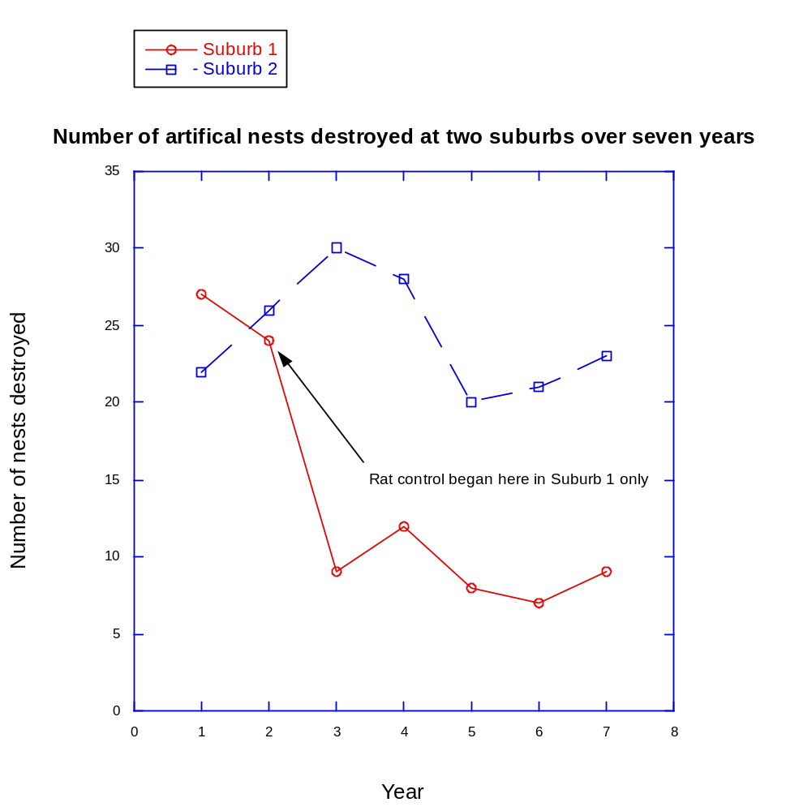
(a) (i) For the experiment described name the following: (2 marks)

The dependent variable.

The independent variable.

(ii) Give two (2) reasons why the researchers monitored the nest destruction for two years before baiting the rats? (2 marks)

(b) (i) What is meant by the term ‘replication’ in experimental design? (2 marks)

(ii) Is this experiment replicated? Explain your answer. (2 marks)

(c) Name four (4) possible factors that could cause fluctuations in the number of nests destroyed at either suburb, from year to year. (4 marks)
1.
2.
3.
4.

(d) (i) What is meant by an experimental control? (2 marks)

(ii) Is this experiment properly controlled? Explain your answer. (2 marks)

(e) Pests are often controlled using poison baits. Describe two (2) important concerns that should be addressed before using poison baits to control pest species. (4 marks)
1.

2.

End of Section Two

Section Three: Extended answer 30% (60 Marks)

Section Three consists of two parts.

Part A mainly tests your knowledge of syllabus content. Part B mainly tests how you apply your understanding of biological principles.

Answers may be presented in different ways provided they communicate your ideas effectively. You may choose to:

- present a clearly labelled diagram;
- write notes beside a clear diagram;
- write lists of points, with sentences which link them;
- write concisely worded sentences;
- use some other appropriate way to present ideas.

Use black or blue pen or ballpoint for written answers and pencil for diagrams. Crossing out of incorrect material is acceptable and preferred to using correction fluid.

Spare pages are included at the end of this booklet. They can be used for planning your responses and/or as additional space if required to continue an answer.
  - Planning: If you use the spare pages for planning, indicate this clearly at the top of the page.
  - Continuing an answer: If you need to use the space to continue an answer, indicate in the original answer space where the answer is continued, i.e. give the page number. Fill in the number of the question(s) that you are continuing to answer at the top of the page.

Suggested working time for this section is 60 minutes.

Part A

Answer any two (2) questions from questions 26 to 29. (30 marks)

Indicate the first questions you will answer by ticking the box next to the question. Write your answers on pages 26–30. When you have answered your first question, turn to page 31 and indicate the second question you will answer on that page.

26. Name and describe five (5) distinct strategies used to maintain biodiversity and prevent extinction. (15 marks)

27. Describe:

(i) the structure and function of the cell membrane. (5 marks)
(ii) how active transport moves materials across the cell membrane.
(5 marks)
(iii) how the structure and function of the cell wall differ from that of the cell membrane. (5 marks)

28. (a) Define the term ‘gene pool’ (1 mark)

(b) Explain how allele frequencies in a gene pool can be changed by:

(i) natural selection. (4 marks)
(ii) sexual selection. (5 marks)
(iii) genetic drift. (5 marks)

29. You are given a fresh sample of tissue from a dead organism but no further information.

(i) Explain how you would prepare this material for examination under a compound light microscope. (6 marks)
(ii) Explain what biochemical tests you could carry out to determine if proteins, carbohydrates or lipids were present in the tissue sample.
(6 marks)
(iii) There are organelles in some of the cells that you suspect may be mitochondria. Explain what cytological or biochemical tests you could conduct to determine if the organelles are in fact mitochondria. (3 marks)

Part A

Indicate the second question you will answer by ticking the box next to the question. Write your answers on pages provided.

26. Name and describe five (5) distinct strategies used to maintain biodiversity and prevent extinction. (15 marks)

27. Describe:

(i) the structure and function of the cell membrane. (5 marks)
(ii) how active transport moves materials across the cell membrane.
(5 marks)
(iii) how the structure and function of the cell wall differ from that of the cell membrane. (5 marks)

28. (a) Define the term ‘gene pool’ (1 mark)

(b) Explain how allele frequencies in a gene pool can be changed by:

(i) natural selection. (4 marks)
(ii) sexual selection. (5 marks)
(iii) genetic drift. (5 marks)

29. You are given a fresh sample of tissue from a dead organism but no further information.

(i) Explain how you would prepare this material for examination under a compound light microscope. (6 marks)
(ii) Explain what biochemical tests you could carry out to determine if proteins, carbohydrates or lipids were present in the tissue sample.
(6 marks)
(iii) There are organelles in some of the cells that you suspect may be mitochondria. Explain what cytological or biochemical tests you could conduct to determine if the organelles are in fact mitochondria. (3 marks)

Part B (30 marks)

Answer any two (2) questions from questions 30 to 33.

Indicate the first question you will answer by ticking the box next to the question. Write your answer on pages 39–43. When you have answered your first question, turn to pages 44–45 and indicate the second question you will answer on those pages.

30. Supervolcanoes in the past are believed to have erupted on a scale far larger than that known for any volcanic eruption in recorded history. Large amounts of ash and other debris were propelled into the upper atmosphere. This greatly reduced sunlight and heat over large areas of the planet for several months. Large-scale population declines of plants and animals and sometimes extinctions of species occurred following these eruptions. Using your knowledge of ecosystems and metabolic processes, explain:

(i) how a supervolcano eruption and its consequences could cause population declines and extinctions. (8 marks)
(ii) what features of plant and animal species would increase their chances of survival under the conditions existing for several months after the eruption?
(7 marks)

31. The diagram below indicates the results of an early experiment used to test the hypothesis that photosynthesis occurs predominantly at particular colours of light. The experimenter shone different colours of sunlight onto a single strand (filament) of a photosynthetic alga (plant) and measured the density of aerobic bacteria around the filament. The results are shown below.
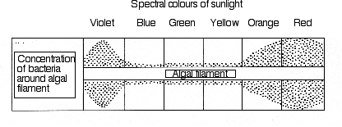
Concentration of bacteria around algal filament
Algal filament
Spectral colours of sunlight
Violet
Blue
Green
Yellow
Orange
Red

An aquarium owner who read about the experiment decided that the knowledge could be applied to control bacterial contamination in his aquarium, where he kept aquatic plants and fish. He placed a filter around the aquarium so that only blue and green light reached the aquarium.

(i) Explain why the bacteria in the experiment were most abundant in some colours of light only. (5 marks)
(ii) Will the treatment reduce bacterial contamination in the aquarium? Explain. (5 marks)
(iii) Could the treatment affect the plants and aquatic animals in the aquarium? Explain. (5 marks)

32. The extinct thylacine was a predatory marsupial belonging to the Metatheria. It was found most recently in Tasmania. The dingo is a predatory placental mammal belonging to the Eutheria. Although these species are not closely related (Metatheria and Eutheria are two sub-groupings within the class Mammalia), they appear very similar as shown in the diagram below. Five thousand years ago the predatory thylacine (marsupial wolf or Tasmanian tiger) occupied all Australia, including Tasmania, before disappearing from the mainland about 3,000 years ago. One hypothesis for its extinction is competition following the introduction of the dingo by Aboriginal people, approximately 4,000 years ago.

(i) Explain how such unrelated animals could come to look so similar.
(10 marks)
(ii) Suggest reasons why these two species could not co-exist when the dingo was introduced to mainland Australia. (5 marks)

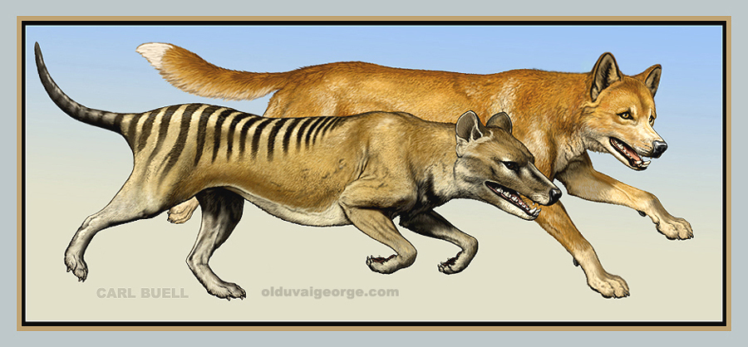
(15 marks)

33. A horticultural company wanted to test the effectiveness of a new fertiliser and a new potting mix for growing vegetables. They prepared 20 pots containing the new potting mix and 20 pots containing plain garden soil. Two tomato seeds were planted in each of the 40 pots. The 20 pots with the new potting mix were placed in a plant growth cabinet set to 24ºC and watered daily with the recommended solution of the new fertiliser. The 20 pots containing garden soil were placed in a second growth cabinet, also set to 24ºC, and watered daily with distilled water only. After a month they measured the height of the seedlings in each cabinet and found that the seedlings in the new potting mix and the new fertiliser were, on average, 10cm taller than those grown in garden soil. They concluded that the new potting mix and the new fertiliser were superior to garden soil.

Evaluate this experimental design, paying particular attention to issues of controlled variables, sample size, replication, and choice of independent and dependent variables.
(15 marks)

Part B (30 marks)

Indicate the second question you will answer by ticking the box next to the question. Write your answer on the pages provided.

30. Supervolcanoes in the past are believed to have erupted on a scale far larger than that known for any volcanic eruption in recorded history. Large amounts of ash and other debris were propelled into the upper atmosphere. This greatly reduced sunlight and heat over large areas of the planet for several months. Large-scale population declines of plants and animals and sometimes extinctions of species occurred following these eruptions. Using your knowledge of ecosystems and metabolic processes, explain:

(i) how a supervolcano eruption and its consequences could cause population declines and extinctions. (8 marks)
(ii) what features of plant and animal species would increase their chances of survival under the conditions existing for several months after the eruption?
(7 marks)

31. The diagram below indicates the results of an early experiment used to test the hypothesis that photosynthesis occurs predominantly at particular colours of light. The experimenter shone different colours of sunlight onto a single strand (filament) of a photosynthetic alga (plant) and measured the density of aerobic bacteria around the filament. The results are shown below.
Concentration of bacteria around algal filament
Algal filament
Spectral colours of sunlight
Violet
Blue
Green
Yellow
Orange
Red

An aquarium owner who read about the experiment decided that the knowledge could be applied to control bacterial contamination in his aquarium, where he kept aquatic plants and fish. He placed a filter around the aquarium so that only blue and green light reached the aquarium.

(i) Explain why the bacteria in the experiment were most abundant in some colours of light only. (5 marks)
(ii) Will the treatment reduce bacterial contamination in the aquarium? Explain. (5 marks)
(iii) Could the treatment affect the plants and aquatic animals in the aquarium? Explain. (5 marks)

32. The extinct thylacine was a predatory marsupial belonging to the Metatheria. It was found most recently in Tasmania. The dingo is a predatory placental mammal belonging to the Eutheria. Although these species are not closely related (Metatheria and Eutheria are two sub-groupings within the class Mammalia), they appear very similar as shown in the diagram below. Five thousand years ago the predatory thylacine (marsupial wolf or Tasmanian tiger) occupied all Australia, including Tasmania, before disappearing from the mainland about 3,000 years ago. One hypothesis for its extinction is competition following the introduction of the dingo by Aboriginal people, approximately 4,000 years ago.

(i) Explain how such unrelated animals could come to look so similar.
(10 marks)
(ii) Suggest reasons why these two species could not co-exist when the dingo was introduced to mainland Australia. (5 marks)

33. A horticultural company wanted to test the effectiveness of a new fertiliser and a new potting mix for growing vegetables. They prepared 20 pots containing the new potting mix and 20 pots containing plain garden soil. Two tomato seeds were planted in each of the 40 pots. The 20 pots with the new potting mix were placed in a plant growth cabinet set to 24ºC and watered daily with the recommended solution of the new fertiliser. The 20 pots containing garden soil were placed in a second growth cabinet, also set to 24ºC, and watered daily with distilled water only. After a month they measured the height of the seedlings in each cabinet and found that the seedlings in the new potting mix and the new fertiliser were, on average, 10cm taller than those grown in garden soil. They concluded that the new potting mix and the new fertiliser were superior to garden soil.

Evaluate this experimental design, paying particular attention to issues of controlled variables, sample size, replication, and choice of independent and dependent variables.
(15 marks)

Additional working space

Additional working space

Additional working space

Additional working space

ACKNOWLEDGEMENTS

Section One

Questions 4–5 Information for text from: Sadava, D., Heller, H.C., Orians, G.H., Purves, W.K., & Hillis, D.M. (2008). Life: The science of biology. (8th ed). Sunderland, MA: Sinauer Associates, p.15.

Graph from: Sadava, D., Heller, H.C., Orians, G.H., Purves, W.K., & Hillis, D.M. (2008). Life: The science of biology. (8th ed). Sunderland, MA: Sinauer Associates, p.15.

Section Three

Question 39 Diagram adapted from: Brown, D.W., & Sewell, J.J. (1984). Australian biology test item bank (Vol. II: Year 12). Melbourne: Australian Council for Educational Research, p.18.

Question 40 Diagram from: Carl Buell. Retrieved January, 2010, from Olduvai George website: http://olduvaigeorge.com/2006/02/20/illustrating-evolution/

Published by the Curriculum Council of Western Australia
27 Walters Drive
OSBORNE PARK WA 6017
This examination paper – apart from any third party copyright material contained in it – may be freely copied, or communicated on an intranet, for non-commercial purposes in educational institutions, provided that it is not changed and that the Curriculum Council is acknowledged as the copyright owner. Teachers in schools offering the Western Australian Certificate of Education (WACE) may change the examination paper, provided that the Curriculum Council’s moral rights are not infringed.

Copying or communication for any other purpose can be done only within the terms of the Copyright Act or with prior written permission of the Curriculum Council. Copying or communication of any third party copyright material can be done only within the terms of the Copyright Act or with permission of the copyright owners.

